Equilibrium Potentials I Lab Notebook
Reading: Equilibrium Potentials I

Name:
Date:
Purpose of Lab:

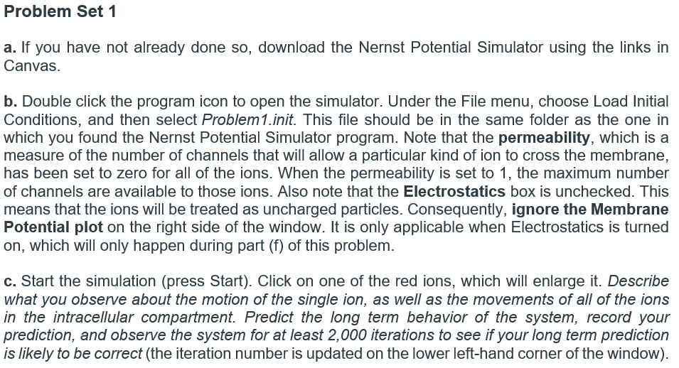

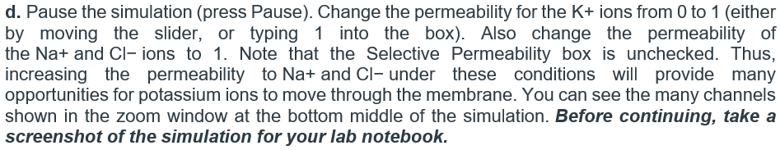

Paste screenshot here. Make sure to label the figure, you can do this by right clicking the image and clicking “Insert Caption”

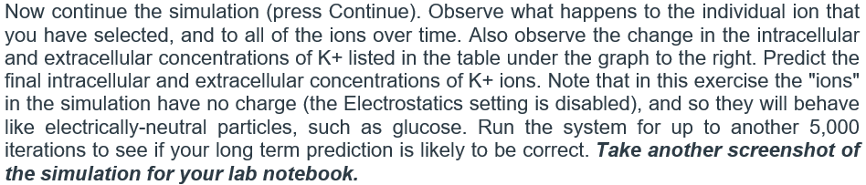
Paste screenshot here. Make sure to label the figure, you can do this by right clicking the image and clicking “Insert Caption”

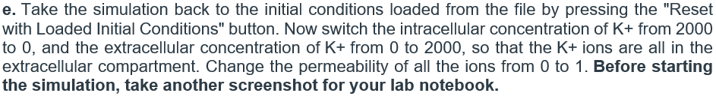
Paste screenshot here. Make sure to label the figure, you can do this by right clicking the image and clicking “Insert Caption”

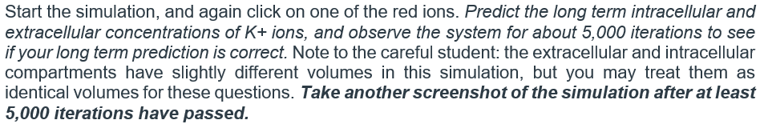
Paste screenshot here. Make sure to label the figure, you can do this by right clicking the image and clicking “Insert Caption”

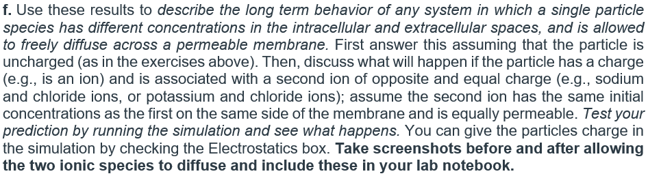

Paste screenshot here. Make sure to label the figure, you can do this by right clicking the image and clicking “Insert Caption”

Paste screenshot here. Make sure to label the figure, you can do this by right clicking the image and clicking “Insert Caption”

