**Action Potential IV Lab Notebook**

**Reading:** [Action Potential IV](https://canvas.case.edu/courses/13687/pages/action-potential-iv-hodgkin-huxley-equations-and-other-conductances)

**Name:**

**Date:**

**Purpose of Lab:**

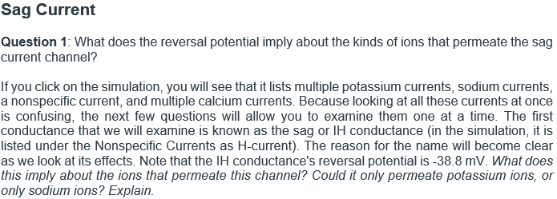

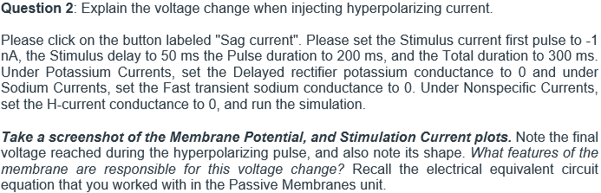

Insert a screenshot of the simulation and label the figure.

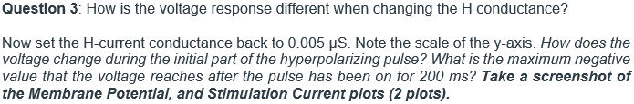

Insert a screenshot of the simulation and label the figure.

Insert a screenshot of the simulation and label the figure.

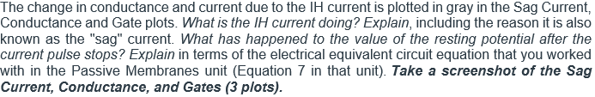

Insert a screenshot of the simulation and label the figure.

Insert a screenshot of the simulation and label the figure.

Insert a screenshot of the simulation and label the figure.

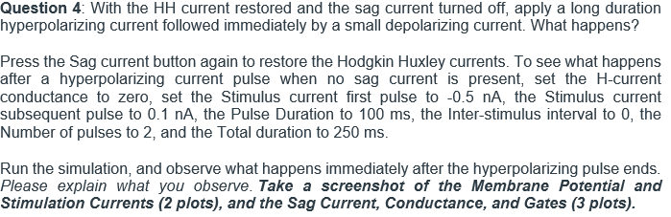

Insert a screenshot of the simulation and label the figure.

Insert a screenshot of the simulation and label the figure.

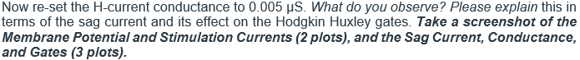

Insert a screenshot of the simulation and label the figure.

Insert a screenshot of the simulation and label the figure.

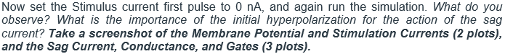

Insert a screenshot of the simulation and label the figure.

Insert a screenshot of the simulation and label the figure.

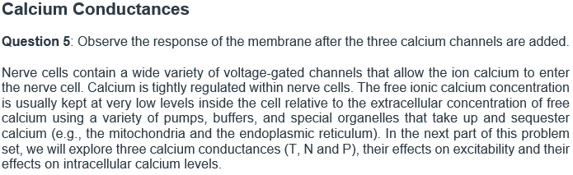

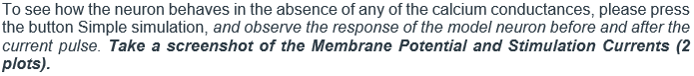

Insert a screenshot of the simulation and label the figure.

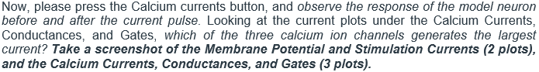

Insert a screenshot of the simulation and label the figure.

Insert a screenshot of the simulation and label the figure.



Insert a screenshot of the simulation and label the figure.

Insert a screenshot of the simulation and label the figure.

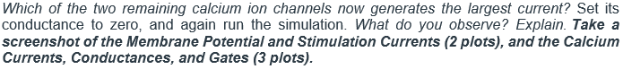

Insert a screenshot of the simulation and label the figure.

Insert a screenshot of the simulation and label the figure.

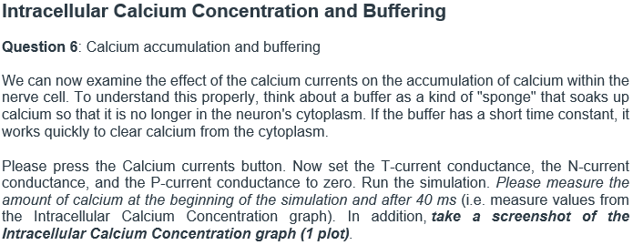

Insert a screenshot of the simulation and label the figure.

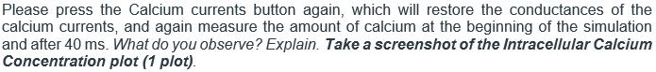

Insert a screenshot of the simulation and label the figure.

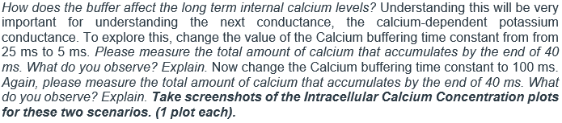

Insert a screenshot of the simulation and label the figure.

Insert a screenshot of the simulation and label the figure.

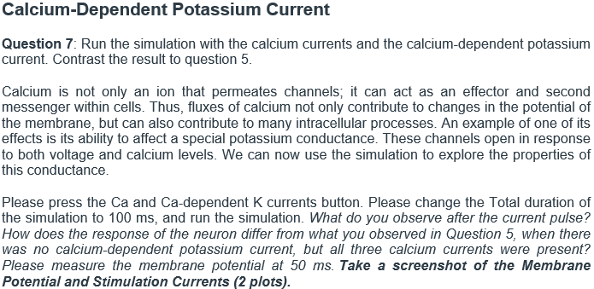

Insert a screenshot of the simulation and label the figure.

Insert a screenshot of the simulation and label the figure.

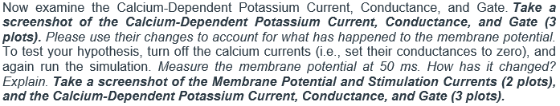

Insert a screenshot of the simulation and label the figure.

Insert a screenshot of the simulation and label the figure.

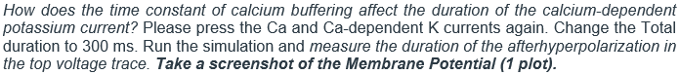

Insert a screenshot of the simulation and label the figure.

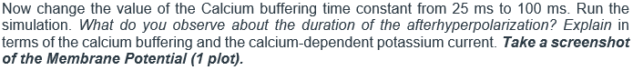

Insert a screenshot of the simulation and label the figure.

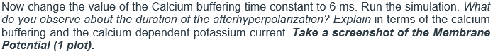

Insert a screenshot of the simulation and label the figure.

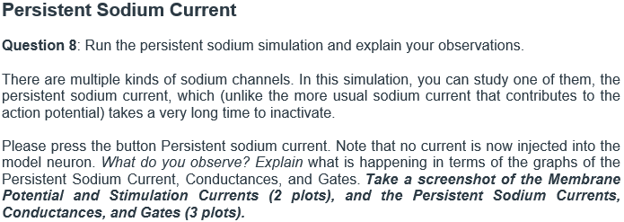

Insert a screenshot of the simulation and label the figure.

Insert a screenshot of the simulation and label the figure.

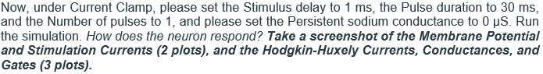

Insert a screenshot of the simulation and label the figure.

Insert a screenshot of the simulation and label the figure.

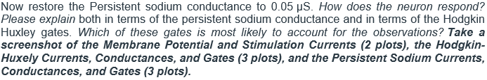

Insert a screenshot of the simulation and label the figure.

Insert a screenshot of the simulation and label the figure.

Insert a screenshot of the simulation and label the figure.

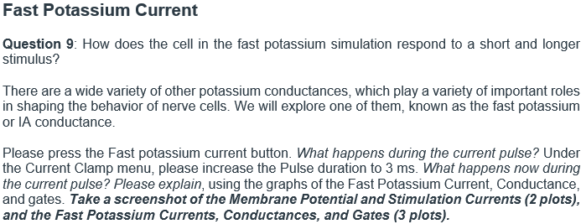

Insert a screenshot of the simulation and label the figure.

Insert a screenshot of the simulation and label the figure.

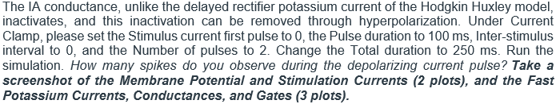

Insert a screenshot of the simulation and label the figure.

Insert a screenshot of the simulation and label the figure.

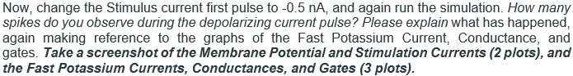

Insert a screenshot of the simulation and label the figure.

Insert a screenshot of the simulation and label the figure.

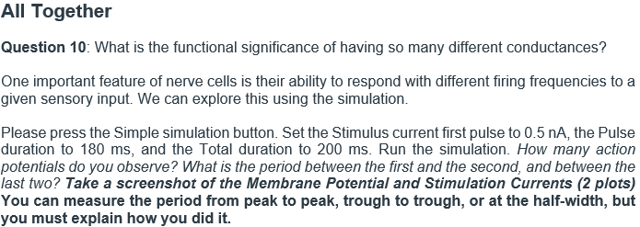

Insert a screenshot of the simulation and label the figure.

Insert a screenshot of the simulation and label the figure.

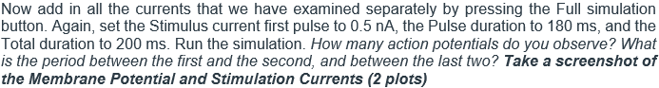

Insert a screenshot of the simulation and label the figure.

Insert a screenshot of the simulation and label the figure.

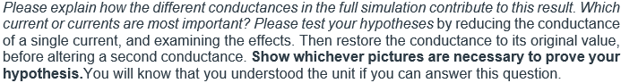

(format this however you would like, please remember to show pictures)

**Discussion:**