Action Potential I Lab Notebook
Reading: Action Potential I

Name:
Date:
Purpose of Lab:

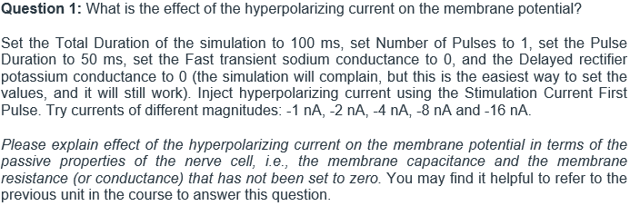

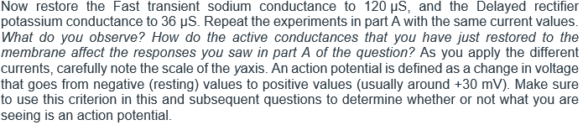

Insert a screenshot of the simulation and label the figure.

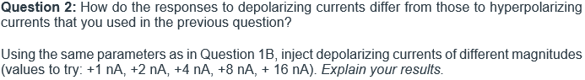
Insert a screenshot of the simulation and label the figure.
Insert a screenshot of the simulation and label the figure.

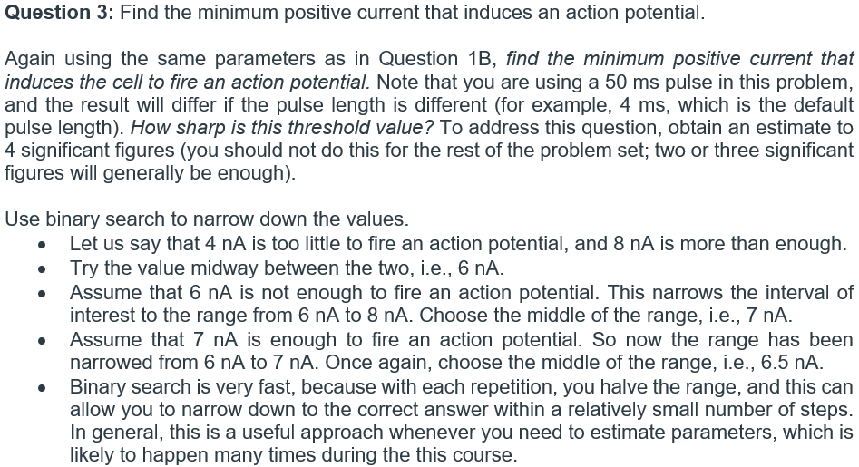

Pulse Duration: | 50ms
Min Positive Current:
Insert a screenshot of the simulation and label the figure.
Insert a screenshot of the simulation and label the figure.

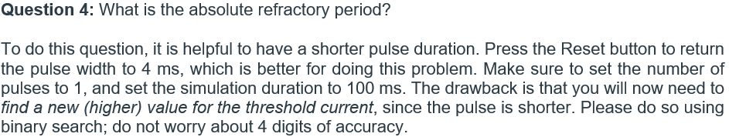

Pulse Duration: | 4ms
Min Positive Current:

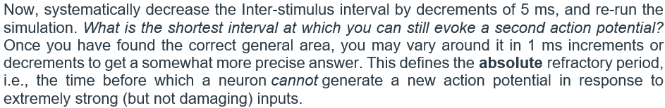

Insert a screenshot of the simulation and label the figure.
Insert a screenshot of the simulation and label the figure.

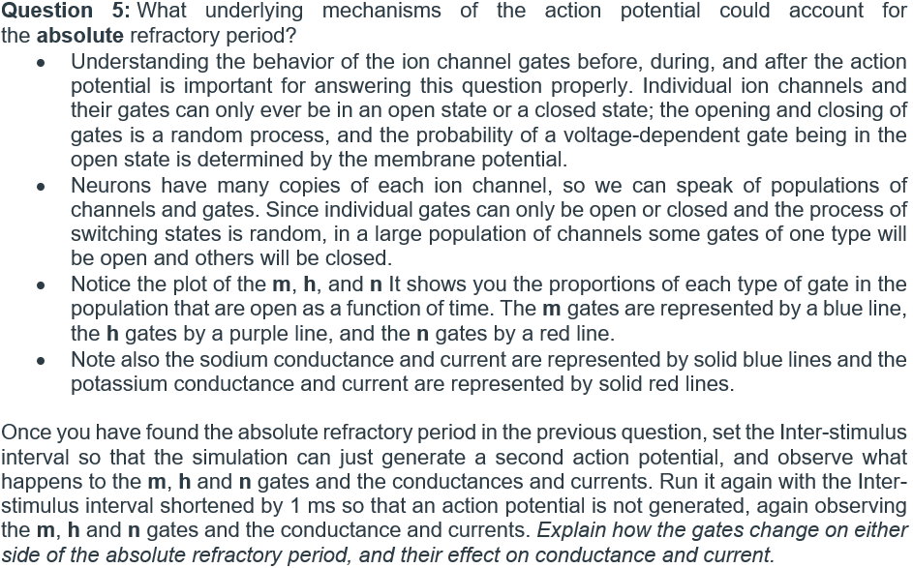

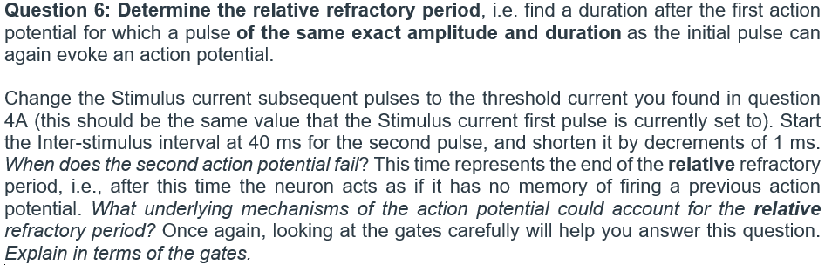

Insert a screenshot of the simulation and label the figure.

Insert a screenshot of the simulation and label the figure.

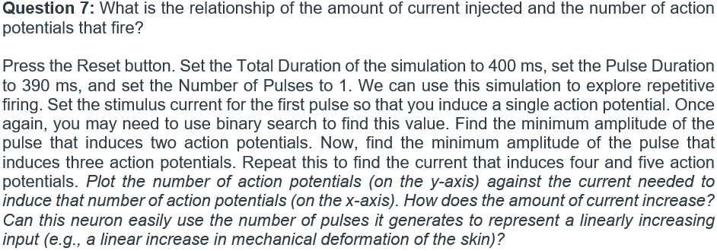

Number of Pulses | Minimum Amplitude
1
2
3
4
5

Insert a plot and label the figure.

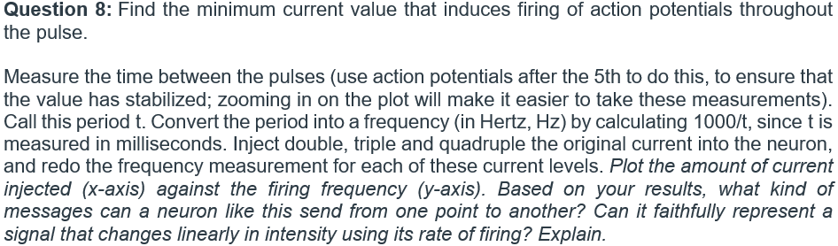

Current I | Period t | Frequency f
Insert a plot and label the figure.

Insert a screenshot of the simulation and label the figure.

