Action Potential II Lab Notebook

Name:
Date:
Purpose of Lab:

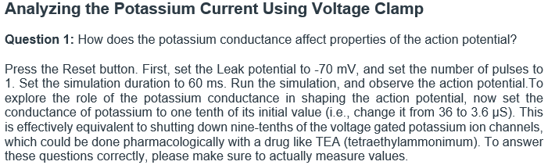
Insert a screenshot of the simulation and label the figure.
Insert a screenshot of the simulation and label the figure.

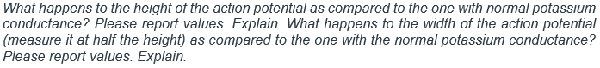

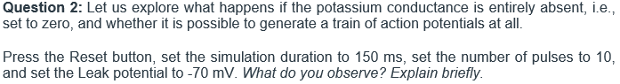
Insert a screenshot of the simulation and label the figure.

Insert a screenshot of the simulation and label the figure.

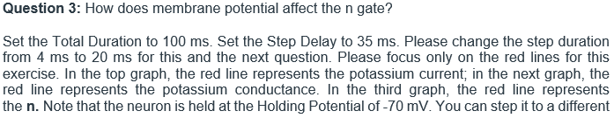
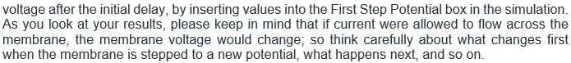

Insert a screenshot of the simulation and label the figure.
Insert a screenshot of the simulation and label the figure.

Insert a screenshot of the simulation and label the figure.
Insert a screenshot of the simulation and label the figure.

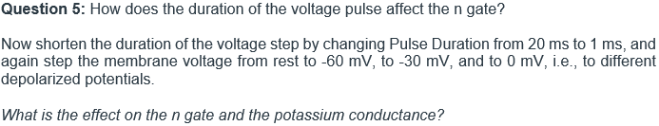

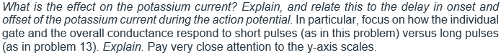
Insert a screenshot of the simulation and label the figure.

Insert a screenshot of the simulation and label the figure.
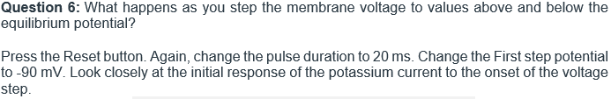
Insert a screenshot of the simulation and label the figure.

