Passive Membranes Lab Notebook
Reading: Passive Membranes

Name:
Date:
Purpose of Lab:

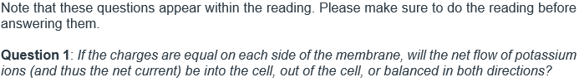

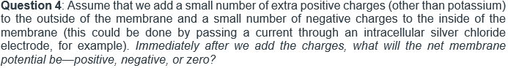

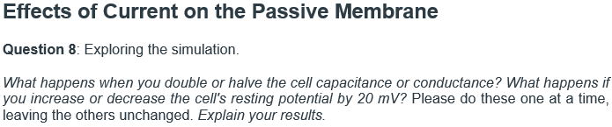

Capacitance
Conductance
Resting Potential

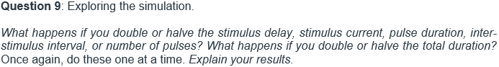

Stimulus Delay
Stimulus Current
Pulse Duration
Inter-Stimulus Interval
Number of Pulses
Total Duration

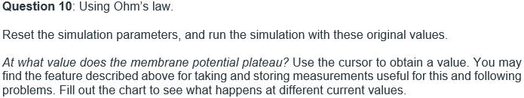
Paste screenshot here. Make sure to label the figure, you can do this by right clicking the image and clicking “Insert Caption”

$$g=2μS$$
$$I_{STIM}$$ | $$V_{MAX}$$
$$10nA$$
$$20nA$$
$$30nA$$

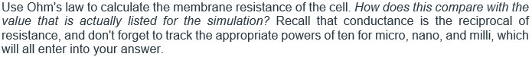

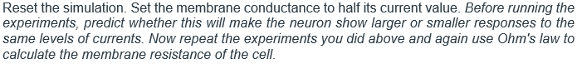

$$g=1μS$$
$$I_{STIM}$$ | $$V_{MAX}$$
$$10nA$$
$$20nA$$
$$30nA$$

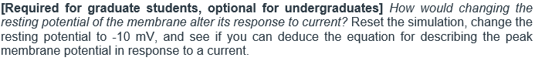

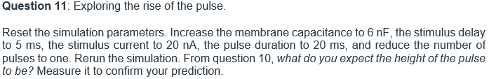
Paste screenshot here. Make sure to label the figure, you can do this by right clicking the image and clicking “Insert Caption”

Length of Time to Reach…
$$\frac{1}{2 } original height:$$
$$\frac{3}{4} original height:$$
$$\frac{7}{8} original height:$$

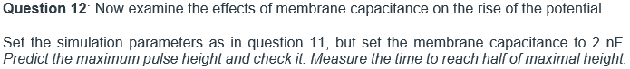
Paste screenshot here. Make sure to label the figure, you can do this by right clicking the image and clicking “Insert Caption”

Membrane Capacitance | Maximum Height
$$4 nF$$
$$6 nF$$
$$8 nF$$

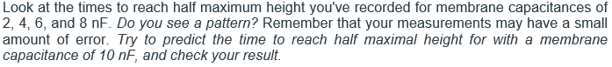

Paste screenshot here. Make sure to label the figure, you can do this by right clicking the image and clicking “Insert Caption”

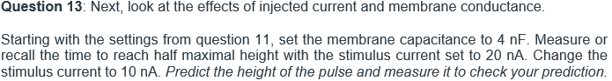
Paste screenshot here. Make sure to label the figure, you can do this by right clicking the image and clicking “Insert Caption”

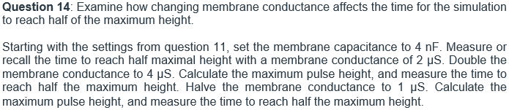

Membrane Conductance | Max Pulse Height | Time to Reach Half Max Height
1 µS
2 µS
4 µS

Paste screenshot here. Make sure to label the figure, you can do this by right clicking the image and clicking “Insert Caption”

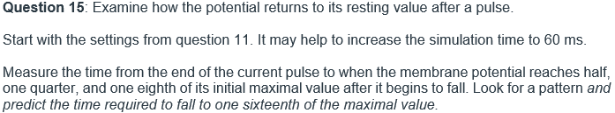
Paste screenshot here. Make sure to label the figure, you can do this by right clicking the image and clicking “Insert Caption”

Length of Time to Reach…
$$\frac{1}{2 } original height:$$
$$\frac{3}{4} original height:$$
$$\frac{7}{8} original height:$$

Membrane Capacitance | Time
4 nF
8 nF

Paste screenshot here. Make sure to label the figure, you can do this by right clicking the image and clicking “Insert Caption”

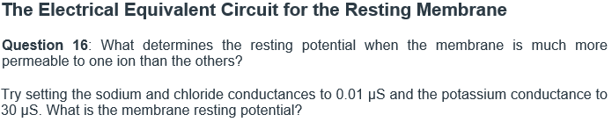

Membrane Resting Potential:

Membrane Resting Potential:

Paste screenshot here. Make sure to label the figure, you can do this by right clicking the image and clicking “Insert Caption”

Paste screenshot here. Make sure to label the figure, you can do this by right clicking the image and clicking “Insert Caption”

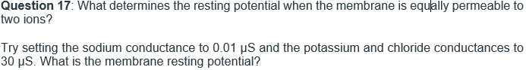

Membrane Resting Potential:

Membrane Resting Potential:

Paste screenshot here. Make sure to label the figure, you can do this by right clicking the image and clicking “Insert Caption”

Paste screenshot here. Make sure to label the figure, you can do this by right clicking the image and clicking “Insert Caption”

